**Leader Overview**



**Volume Overview**

**Get Going**

*The gift of the Holy Spirit was sent so that we might have power—power to go and make disciples. Some go to the farthest corners of the globe. Some only cross the street in front of their house. Still, God’s people always go. They go to work, school, grocery stores, kids’ soccer games, and family reunions. And wherever they go, they take their witness of Jesus with them. True believers live going and carrying out His mission.*

**Session Overview**

**Share the News**

*In this* **Live** *session, preschoolers will explore the power of God’s love to dramatically transform lives. We’ll look at the story of Matthew, a tax collector who made wrong choices. After embracing Jesus’ love, he became a disciple and invited his friends to meet Jesus. Preschoolers will discover their role in sharing God’s love with others.*

**Bible Lesson**

Matthew Follows Jesus

[Matthew 9:9–13](https://ref.ly/logosref/Bible.Mt9.9-13)

**Faith Fact**

I can share God’s love.

**Faith Verse**

[John 20:21](https://ref.ly/logosref/Bible.Jn20.21) (NLT)

[Jesus] said, “Peace be with you. As the Father has sent me, so I am sending you.”

**Preparing for the Session**

**Leader Preparation Time: 20–25 Minutes**

|  |
| --- |
| ***You Will Need***  ***Preservice Activities***  *• Toys*  *• Ball*  *• Prepackaged snack of your choice, one per kid*  *• Hand sanitizer*  ***Large Group***  *• Bible*  *• Worship songs (Song suggestions: “Do What You Wanna Do” Lyric Video by Elevation Church Kids; “I Know I Belong” Lyric Video by Saddleback Kids*  *• For groups not using a phone or tablet only, add:*  *• Projector or TV*  *• Laptop*  *•* ***Faith Fact Sound*** *video (bell ringing)*  *•* ***Faith Fact Slide***  *•* ***Faith Verse Slide*** *or* ***Video***  *•* ***Bible Lesson Video A***  *•* ***Bible Lesson Video B***  ***Small Group***  *•* ***Small Group Activity Page****, one per kid*  *• Crayons or markers*  *• Two complete place settings for each group playing at the same time (plate, cup, silverware, napkin, placemat, etc.)*  *• Table*  *• Box or bag*  *• Red balloons, one to two per group*  *• Permanent marker*  *To access session content and videos from a computer, visit:* [***BibleEngagementProject.com/downloads***](https://bibleengagementproject.com/downloads) |
| ***Getting Ready***  ***Preservice Activities***  *• Set out toys and snacks.*  ***Large Group***  *• Download videos and slides if needed.*  *• Select worship song(s) and have them ready to play.*  ***Small Group***  *• Print copies of the* ***Small Group Activity Page****, one per kid*  *• Set up one of the place settings on the table.*  *• Put the items for the other place setting in a box or bag.*  ***First time leading* Live *for Preschool? Check out the*** [**Facilitator Guide**](https://0b769b0ed3569ef9d18b-f88d8272f61086866d50d048b43ef630.ssl.cf2.rackcdn.com/sites/biblengagementproject/Listen_Facilitator_Guide.pdf)**.** |

**Preservice Activities**

*See what’s needed at the beginning of the session.*

**Bible Story Warm-Up**

Today, we’ll talk about sharing something very important with others. So I thought we should practice sharing with each other first. *(Hold up the ball.)* This is the answer ball. That means if somebody’s holding it, they get to share with us. I have a lot of questions because I want to get to know you better. After I ask a question, whoever gets the ball will answer my question. Then, they will roll the ball to someone else to answer the question. Once you answer a question, you need to hold your hands in your lap so your friends know you’ve already had a turn. Don’t worry because everyone will get a chance to share today.

• *Sample questions: What is your favorite thing to do for fun? What is your favorite color? How did you help someone this week? What do you like best about being here with us?*

• *Continue to play until everyone gets a chance to share.*

Was it easy or hard to wait for your turn?

Do you enjoy sharing and talking with other people?

What was your favorite thing that you learned about someone else?

My favorite thing that I learned was *(insert fun fact about a kid)*. You all did a great job taking turns and sharing. Today, we’ll learn about something that Jesus wants us to share with other people. Can you guess what it might be? *(Allow responses.)* Jesus wants us to share God’s love with others. I’m so excited to get to learn more about this with you.

**Snack**

**Leader’s Choice**

For snack today, I’ll need everyone’s help. If you think you can help me, raise your hand. Awesome! I knew you would all be excellent helpers. First, everyone needs to clean their hands.

• *Give kids hand sanitizer to clean their hands.*

Now, you can help me with the snacks. I’ll give one snack to the person closest to me. Then, they’ll pass it to the next person without opening it. Everyone will help by passing until the last person gets the snack. Then, we’ll start over and keep passing snacks until everyone has one. Sound good? *(Group response)* Let’s go.

• *Hand out the snacks to the group.*

Thanks for helping to share the snack with everyone! Go ahead and eat it. It’s always fun to share, but it’s even more fun when our sharing helps someone else. We all have something very special to share with people—God’s love. We’ll find out more in our Bible time today.

**Free Play**

*Any extra time can be spent playing with toys.*

**Transition**

*A few minutes before service begins have kids make their way to the large group area and sit in their designated areas.*

**Large Group**

**25 Minutes**

*See what’s needed at the beginning of the session.*

**Introduction**

Hi, friends! I’m so excited that we get to be together today! My name is _________. On the count of three, shout out your name. 1, 2, 3. *(Group response)* Wow! I’m so glad that all of you are ready to explore God’s Word with me. *(Hold up the Bible.)* If you’re excited to be here, raise your hand. *(Group response)*

Today, we’ll learn about Jesus and His great love for people. He came to earth to share God’s love with everyone, including a man named Matthew and his friends. There is one no one else like Jesus.

**Faith Fact**

Jesus wants you and me to have His love in our heart so we can share God’s love with others. That’s our Faith Fact today: **I can share God’s love.**

• *Show the* ***Faith Fact Slide.***

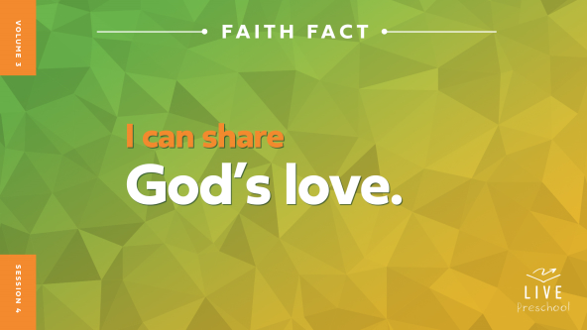

Repeat the Faith Fact after me. **I can share God’s love.** Great! Let’s shout it together now. **I can share God’s love.** I wonder if you can say it even a little bit louder. Do you think so? *(Group response)* Let’s hear it! **I can share God’s love.**

**Bible Time**

There is a very special book that teaches us about God’s love. Can you think of what book that is? *(Group response)* Yes! Of course, it’s the Bible. *(Hold up the Bible.)* We love exploring Bible stories with Lizzy and Grandpa, don’t we? *(Group response)* Let’s see what Lizzy is doing today.

• *Play* ***Bible Lesson Video A.***

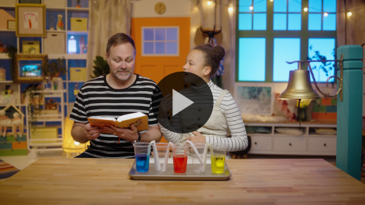

I’m glad Grandpa gave us a little time to think about that clue. Let’s worship God together now. Then, I’ll ask you about what’s going to happen next in our Bible story.

**Worship**

When I think about how much God loves me, I want to give Him all my praise and worship. Let’s tell God how thankful we are for His great love.

**Praise**

Who knows that God loves us so much? Run in place as fast as you can. *(Group response)*

Who wants to share God’s love with others? Stretch your arms as wide as they can go. *(Group response)*

Who wants to praise God with everything you have? Wave your hands up high. *(Group response)*

**Sing**

I love hearing your praises, and I’m not the only one who hears your voice when you sing. Who else hears your praise? *(Group response)* God does! Let’s sing to Him together.

• *Lead the kids in singing one or two songs. See song suggestions at the beginning of the session.*

**Prayer**

The Bible says our praise is pleasing to God. He loves to be close to us, and we can learn how good He is. Let’s bow our heads and pray.

|  |
| --- |
| *Dear God, thank You for Your great big love that surrounds us and never lets us go. I pray these kids stay close to You every day of their life. Keep them in Your care today and every day. Amen.* |

**Bible Time cont’d**

• *Start* ***Bible Lesson Video B*** *and pause on the image of the two choices.*

It’s about time for Grandpa and Lizzy to come back. Let’s think about the answer to what happens next. Put on your thinking caps *(demonstrate)*. What do you think? Did Jesus and the disciples say no to eating at Matthew’s house? *(Point to the “empty plate” graphic.)* Or did Jesus and the disciples go to Matthew’s house to eat? *(Point to the “plate with food” graphic.)*

If you think Jesus and the disciples didn’t go to Matthew’s house, cross your arms in front of you like an X. If you think Jesus and the disciples did go to Matthew’s house for dinner, pretend to eat your favorite food. Ready? Choose your answer.

• *Pause while kids respond.*

Let’s find out if you’re right! Let’s check back in with Lizzy and Grandpa.

• *Play* ***Bible Lesson Video B.***

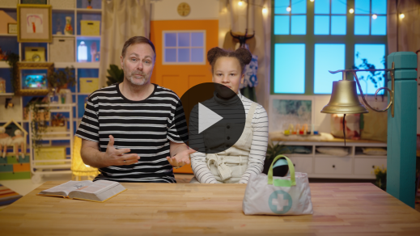

Wow! Did you like seeing the colors go through the paper towels? *(Group response)* Me, too! I agree with Grandpa that the most beautiful thing is sharing God’s love with others.

**Response Time**

*Play a worship song quietly.*

I think we need to respond to God’s Word. Can you put your hands over your heart to show that you want to let God’s love fill it? *(Group response)* Now, let’s put our hands out to show we want to share His love with others. *(Group response)* God’s love is the best gift we can tell others about.

• *Have the kids repeat phrases of the prayer after you.*

|  |
| --- |
| *Dear God, thank You so much for filling my heart with Your love. I want to share Your love with others. Help me to share Your love this week with my family at home and with my friends. Amen.* |

**Faith Verse**

When we learn Bible verses, we’re planting God’s Word in our heart. Our Faith Verse is another reminder for us to share God’s love. Let’s say our Faith Verse and do the actions together.

[John 20:21](https://ref.ly/logosref/Bible.Jn20.21) (NLT)

[Jesus] said, “Peace be with you. As the Father has sent me, so I am sending you.”

• *Show the* ***Faith Verse Video.***

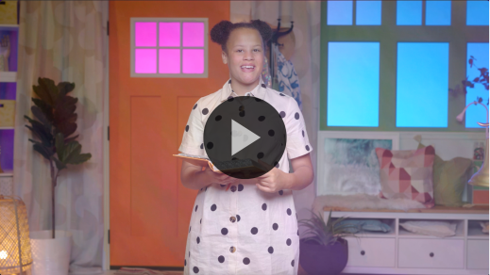

Great job, everyone! We’re getting that verse down!

**Closing**

I’ve had such a great time with all of you today! I’m so glad you came so we could explore God’s Word together. We also sang and worshipped God. We talked to God in prayer, and we learned a great Faith Verse from the Bible. I can’t wait to hear how God uses you to share His love with others.

• *Play the* ***Faith Fact Sound*** *video (bell ringing).*

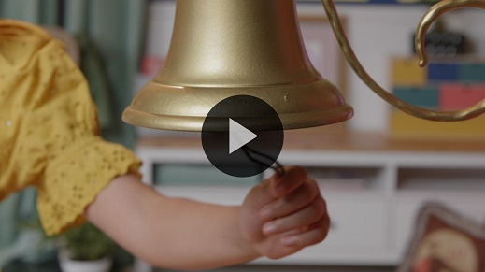

We have time to say our Faith Fact one more time! **I can share God’s love.**

• *Show the* ***Faith Fact Slide.***



Let’s share that Faith Fact with the whole world. Shout it out! **I can share God’s love**.

**Dismissal to Small Groups**

You did that so well! It’s time to do some activities and continue learning about God’s love in our very special small groups.

• *Dismiss the kids by groups.*

|  |
| --- |
| ***Leader Tip:*** *This can be done by assigning color teams or by age groups. Note that some young preschoolers may not know their age. Using a colored sticker, jersey, or wristband will help separate the kids and help identify their small groups.* |

**Small Group**

**25 Minutes**

*See supplies and prep instructions at beginning of session or in each activity below.*

|  |
| --- |
| ***Leader Tip:*** *Small groups can alternate to each circle, or all groups can do each activity at the same time. If you choose to alternate, you will need at least one leader per circle.* |

**Circle 1**

**Group Connection**

**Share a Smile**

|  |
| --- |
| *No prep needed for this activity.* |

* *Have kids sit in a circle.*

Have you had fun so far today? *(Group response)* I know I’ve had a lot of fun! Today, we’ve learned about something very important we can share with other people. What is it? *(Group response)* That reminds me of our Faith Fact. Can anyone tell me what it is? *(Allow responses.)* That’s right. **I can share God’s love.** Everyone, say it with me. **I can share God’s love.** *(Group response)* That was so good!

Let’s practice one way we can share God’s love with others. I’ll share a smile with the person sitting next to me. I want to see if my smile can make it all the way around the circle. Keep passing the smile around the circle until it gets back to me. Let’s try it!

• *Pass the smile around the group by having each kid smile at the person next to them.*

Great job, everyone! That was fun to share a smile. That’s one way we can share God’s love with others. Now, I’ll make it a little harder. I’ll share a new expression, but this time it won’t be so happy. I’ll make a sad face. When the person next to you shares the sad face, you need to respond by sharing God’s love with them. You might smile back at them. What are other ways to show them God’s love? *(Allow responses.)* Sometimes it’s comforting to get a hug or a pat on the shoulder. Sometimes it’s nice to say, “God loves you.” There are many ways to share God’s love when someone is sad. Remember to choose one of those ways to respond when it’s your turn. Then, pass on the sad face to the next person so they can share God’s love with you.

• *If you have time, continue playing with other expressions: laughter, mad face, etc.*

• *End the activity by passing the smile again.*

That was fun! You are good at sharing God’s love with others. As you go throughout your day, you can share lots of things with other people. You can share your happiness, a toy you’re playing with, or maybe your snack. All those things are great to share, but the best thing you can ever share with someone is the exciting news that God loves them.

**Circle 2**

**Activity Page Time**

**Follow Me**

|  |
| --- |
| **You Will Need**  • **Small Group Activity Page**, one per kid  • Crayons or markers  **Getting Ready**  • Print copies of the **Small Group Activity Page**, one per kid. |

In our Bible story, we learned that Jesus came to help people that some others didn’t want to help. Jesus came to share God’s love with everyone. Our Faith Verse tells us to go and share God’s love with others like Jesus did. I think this is a perfect time for us to practice our Faith Verse. Let’s all say it together.

• *Lead kids in saying Faith Verse and doing the actions.*

**John** *(hands at waist, spread apart, palms up and out)*

**20:** *(hands together like a clap)*

**21** *(hands opened to “book”)*

**Jesus said**, *(sign language for Jesus—middle finger touches center of opposite hand palm on both hands)*

**“Peace be with you.** *(wrap arms around each other like giving yourself a hug)*

**As the Father has sent me**, *(point up both index fingers for Father)*

**so I am sending you.”** *(sign language for Jesus—middle finger touches center of opposite hand palm on both hands then both index fingers point away from body)*

On your Activity Page, you’ll tell us who you can share God’s love with.

• *Hand out a copy of the* ***Small Group Activity Page*** *and crayons to each kid.*

Our page says, “I can share God’s love with …” Remember how Matthew invited his friends to spend time with Jesus? Matthew wanted them to know about God’s love. We can do that too. Your family and your friends need to know that God loves them. Who are people you can share God’s love with? *(Allow responses.)*

Inside the heart, I want you to draw a picture of who you’ll share God’s love with this week. When we share God’s love with other people, we’re doing exactly what Jesus is sending us to do.

• *Give kids time to complete the page. Talk with them about who they are drawing on their page.*

**Circle 3**

**Feet-to-Floor Game Time**

**Party Prep Relay**

|  |
| --- |
| ***You Will Need***  *• Two complete place settings for each group playing at the same time (plate, cup, silverware, napkin, placemat, etc.)*  *• Table*  *• Box or bag*  ***Getting Ready***  *• Set up one of the place settings on the table.*  *• Put the items for the other place setting in a box or bag*. |

I can’t wait to play this game. Is anyone else excited to play a game with their friends? *(Group response)* Talking about friends reminds me of our Bible story. What did Matthew do with his friends? *(Allow responses.)* Matthew invited others to a dinner at his house so they could meet Jesus. We’ll pretend that we’re helping Matthew get ready for his dinner. I’ve already got one of the place settings ready.

• *Show kids the place setting that is complete.*

Your job is to help with the next place setting. We’ll work together and race to see how fast we can get it set up to match the sample I did. First, you’ll line up away from the table.

• *Choose a starting line away from the table.*

When it’s your turn, you’ll run to the table, choose an item for the place setting out of the box, and put it in place. Then, you’ll run quickly back to the group so the next person can go and help. Let’s play.

• *Optional: Time the group to see how quickly they can set the table.*

• *During the activity, interrupt and practice the Faith Fact:* **I can share God’s love.**

• *Play the* ***Faith Fact Sound*** *video. Review the Faith Fact even if you can’t play the sound.*



Great job, everyone! You were very helpful by setting the table. Now, you can show God’s love to your family and set the table at home, too.

**Circle 4**

**Hands-On Learning**

**Spreading Love**

|  |
| --- |
| ***You Will Need***  *• Red balloons, one or two per group*  *• Permanent marker*  *No prep needed for this activity.* |

I love balloons! They can be so much fun. *(Hold up a deflated balloon.)* Hmm. This balloon doesn’t look very exciting. There’s nothing in it yet. If I blow it up, there’s a lot more we can do with it. *(Blow up the balloon but don’t tie it.)* I could let it go. Would that be fun? *(Group response)* Let’s find out.

• *Let the balloon go and then retrieve it.*

Hmm. That was a little bit fun. I think I need to blow it up again. *(Blow up the balloon but don’t tie it.)* Maybe it would be fun to pop it. Should I poke the balloon with something sharp? *(Group response)* That doesn’t sound like fun that would last very long. I know the best way I could have fun with this balloon! I could share it with you so we could play a game. Let’s pretend that this balloon represents God’s love.

• *Tie off the balloon.*

• *Write* God’s Love *on the balloon with a marker.*

What does our Faith Fact say? **I can share God’s love.** Let’s see how many times we can share God’s love with each other. Let’s work together to keep the balloon in the air and count how many times we hit it.

• *Toss the balloon up in the air and count each time someone hits it.*

• *When the balloon falls to the ground, pick it up and start over with the counting.*

I knew we could have fun by sharing! This is a reminder that God’s love is great to experience, but it’s so much more fun when you share it with other people. Remember to share His love with others this week. Thanks for playing!

**Dismissal**

• *Play the* ***Faith Fact Sound*** *video (bell ringing).*



• *Show the* ***Faith Fact Slide.***



Well friends, that’s just about all the time we have for today. I have had so much fun learning with you today. Before we go, I want to say the Faith Fact together one last time. **I can share God’s love.** Amazing! While you’re at home, school, or wherever this week, remember that you can share God’s love. See you next time!

• *Send home the* ***Small Group Activity Page*** *with each kid.*

• *Remind parents that there are* ***Family Devotions*** *available on the app to do with their kid.*

• *Tell everyone the date and time for the next session.*

.